The world of graphic design offers a diverse landscape of potential positions, allowing you to specialize in an area that aligns with your interests and skills. Here's a glimpse into some exciting possibilities:

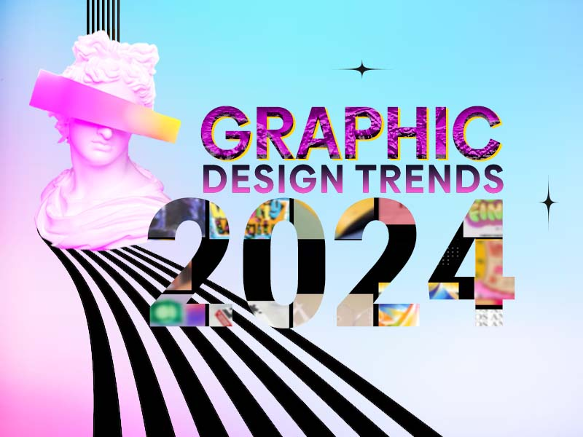

* **Brand Identity Designer:** For those who crave a strategic challenge, brand identity design is a captivating path. These designers are the architects of a company's visual identity, crafting logos, color palettes, and typography that define the brand's personality. They work closely with marketing teams to ensure brand consistency across all media, from packaging to websites.
* **User Interface (UI) / User Experience (UX) Designer:** In the digital age, UI/UX designers are the magicians behind the curtain. They craft user interfaces for websites and apps, ensuring they are not only visually appealing but also intuitive and user-friendly. Understanding user behavior and information architecture is key for this role. UI/UX designers play a crucial role in creating seamless digital experiences that keep users engaged and coming back for more.
* **Publication Designer:** For those with a love for storytelling and layout, publication design offers a fulfilling path. These designers create the visual framework for magazines, newspapers, and books. They combine text, images, and white space to create a visually engaging and informative experience for readers. Strong knowledge of typography and layout principles is essential for publication designers, who play a significant role in shaping how readers navigate and consume information.

This is just a taste of the exciting possibilities within graphic design. From crafting packaging that pops on shelves to designing captivating marketing materials, there's a niche for every creative mind. So, if you possess a passion for visual communication and a desire to bring ideas to life, the world of graphic design awaits you.